Trees in Autumn in some of London’s Parks and Commons
A cycle ride in the Southwark Cyclists Healthy Rides Series on October 25th 2025.
Written by Jean Sutton, who led the ride.
We were hoping for a dry day on Saturday and indeed it started with a beautiful blue sky. Ten riders met at Dulwich Park for the planned Parks and Commons ride.
The introduction started with a mention that the London Trees map at the London.gov.uk website shows the locations and species information for over 1,100,000 of London's public realm trees . These are predominantly street trees and trees in parks and other open spaces. As an interactive map you can actually hover on your street and find details of the tree outside your house !
Since we normally leave directly from the Café out of the College Road Gates, we began this time with an anti-clockwise round of the park to enjoy the amazing view of the park trees- starting with one of the many boundary Oaks (that once marked the edges of old fields or estates, and which survive in the park today.) just adjacent to the boats at the lakeside. There is a huge amount of information about the trees of Dulwich Park on the Dulwich Society website.
We then left the park turning left instead of our normal right turn and crossed over to Dulwich Picture Gallery where there are 26 different species of tree in their small public sculpture garden. (including a Judas Tree just in front of the Gallery entrance) - so called because it is said that Judas hung himself from one such tree). A map and listing of these is also on the Dulwich Society website.
We went by Burbage Road and Winterbrook Road under the railway bridge at Herne Hill to cross over to Brockwell Park. Stopping inside the gate, John who was our tree identifier for the day- pointed out a few of the trees in our line of sight including a fine Ash and a Turkey Oak and also a beautiful yellow Hornbeam outside the Lido. There are some 1700 trees in the Park.
Towards the back of the park we stopped at the big conker sculpture just inside the Brixton Water Lane entrance carved out of wood from a Giant Redwood tree by Daniel Miles, a sculptor based in Port Isaac, North Cornwall.
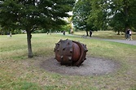

We went over to Clapham Common to turn left on Windmill drive where we stopped to admire
the lovely trees around the Mount Pond. Clapham Common is mentioned as far back as 1086 in
the famous ‘Domesday Book’, and was originally ‘common land’ for the Manors of Battersea
and Clapham .J. M. W. Turner painted "View on Clapham Common" between 1800 and 1805.
Many of the large trees on the Common were planted before 1895, mainly in avenues, and now
exist as stately specimens of London Plane and Lime (Linden). It has some 2,500 trees – some
30 different species, and two small areas of woodland.

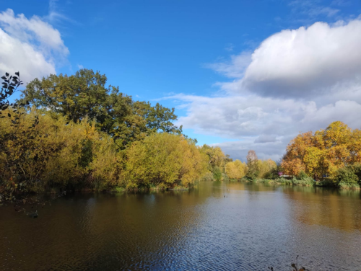

We crossed the South Circular Rd at the further edge of the common and down Thurleigh Road to Wandsworth Common. Some of the paths there are ‘no cycling’ so we stuck to the allowed route- crossing over the railway bridge to the Skylark Café. Service there was unfortunately particularly slow but we were happy to sit and chat outside in the fine weather and wait for the drinks to be brought out to us.

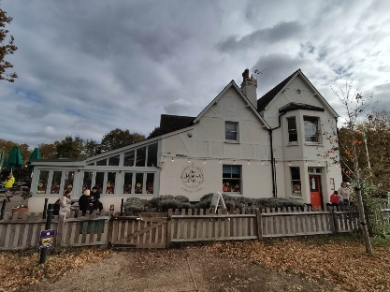

After the break we went over the beautiful pond and saw tall swamp cyprus (initially wrongly identified by an app as a Redwood – of which there are many in the UK) a Black Locust and a Russian Olive tree by the side of the water. There are an estimated 3500 trees on the Common.

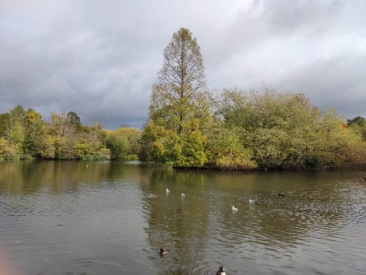

Our return route was mostly a retracing of our outbound but we stopped at the Brixton windmill where there was a peaceful Tai Chi class going on and John pointed out the plane trees and silver Birch. London planes are hybrids, bred for city life; they filter pollution through their bark.
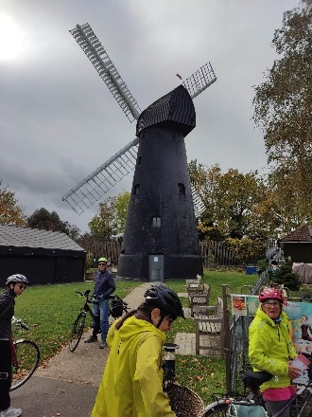
Back to Dulwich via Brockwell Park, Rosendale Road cycleway and Turney Road to Dulwich Park. We were lucky with the beautiful sunny day showing the Autumn trees in their best light.
