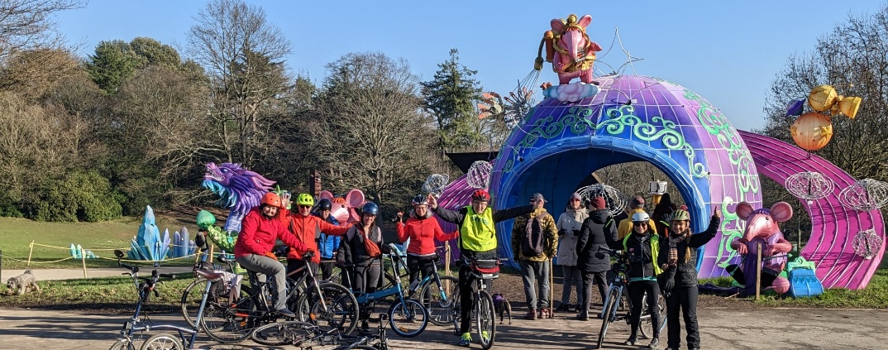
The Clangers were in Crystal Palace Park! Ride Jan 2023, leader Amanda.
Annual Report Southwark Healthy Rides Nov 22 – Oct 23
By Bruce Lynn, Healthy Rides Co-ordinator, Southwark Cyclists 14 Nov 2023
Stats. 95 rides, same as 21-22. Average number of riders 12, down a touch on 21-22. Pre Covid (2019) we were doing just 53 rides, but averaging 17 riders/ride.
Ride Leaders. 95 rides means lots of ride leaders planning and checking routes and delivering the ride itself. We have built up a group of people prepared to lead rides and a few others who help with marshalling. 14 different people helped during 22-23: David Senior, Simon Kenward, Jamie Pedrick, Amanda Upton, Jean and John Sutton, Jane Champion, Mike and Mary Kearns, Simon Saville, Eva Bigalke, Werner Wiethege, Eduardo Grazioli, Peter Battams. I am extremely grateful to them all.
Overview. As last year we have done occasional longer rides, using most of the day. These are very popular. We celebrated several anniversaries: including two BBC centenary rides, the second one 80km, our longest ride yet. We celebrated 75 years of the NHS and experimented with doing the ride twice, first in the morning then repeated in the afternoon. Recently we did a couple of Wren 300 rides.
Miscellaneous. As in previous years we helped organise a group picnic with other rides groups in Greenwich Park. The Facebook group grows, now 388, but not very active. The WhatsApp group has 30 members and is active during and after rides – lots of photos. The Google Group we use for ride notices now has 308 on the list, up from 285 a year ago.
Future. Plenty of people enjoy these easy-paced, social rides. Now we are post Covid be helpful to reduce the paperwork. Plan to discuss this with LCC in relation to the new events calendar available on the LCC web site. One of the aims of the rides is to help less confident cyclists develop their cycling. But we see very few people like that. Need to think of some better ways to encourage newish cyclists to try the rides – maybe some “marketing” in Spring 2024.

