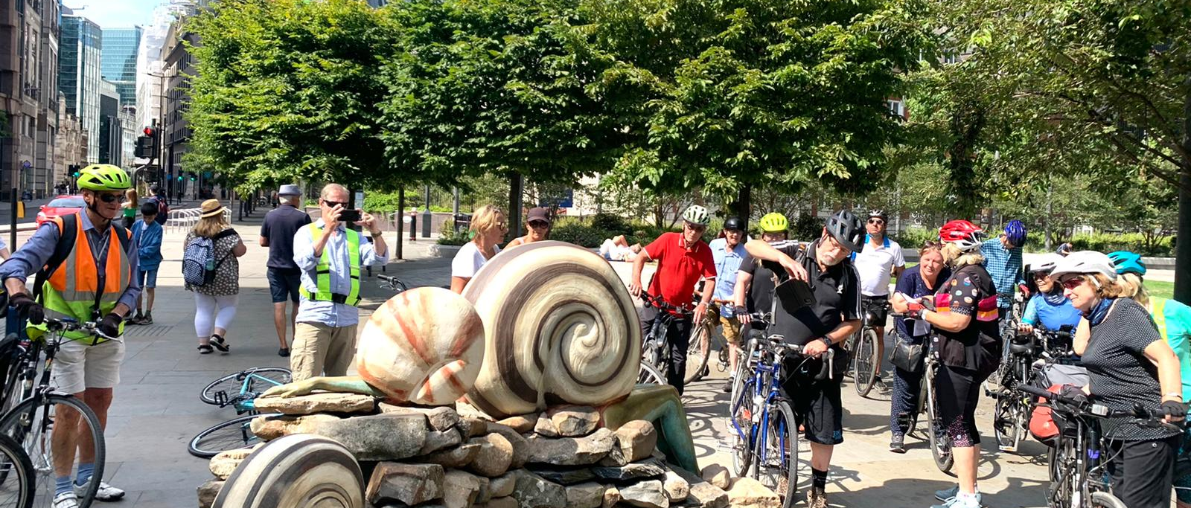
Sculptures in the City Ride led by Eva
Annual Report on the Southwark Healthy Rides 2021-2

Bruce Lynn, Healthy Rides Co-ordinator, Southwark Cyclists. 7 November 2022
Stats. 95 rides, average number of riders of 13. Compared with 66 rides with an average of 11 last year. Last year there were still restrictions early on due to Covid. Most recent Covid free year was 2019 when we had 53 rides with an average of 17.

Ride Leaders. The higher number of rides, 2 per week when Saturdays were available, were made possible by the great group of people who now help by leading rides. 14 different people helped by leading rides or marshalling: David Senior, Simon Kenward, Jamie Pedrick, Philippa Goffe, Amanda Upton, Jean and John Sutton, Jane Champion, Mike and Mary Kearns, Simon Saville, Juliet Filose, Eva Bigalke, Werner Wiethege. I am extremely grateful to them all. Southwark Cyclists could not offer such a terrific range of rides without their support.
Overview of 2021. It was nice to be free of Covid restrictions. We have enjoyed creating new rides while still revisiting many favourites. Riders are getting more adventurous. We had 4 rides of more than 5 hour duration, i.e. not just the morning any more. Most impressive was the “awayday” ride to Windsor Great Park organised by Jamie Pedrick. We plan to have more of these. We also had our first midweek ride to deal with the big response to the Saturday ride for International Womens Day led by Jane Champion.
Miscellaneous. As well as the rides, we organised 2 picnics and helped with the Ride London guiding. The Facebook Group now has 337 members, the Google group who get automatic ride notifications numbers 285. Without any input from me, we now have a WhatsApp Group called “The Vulnerables” with 28 members. I have no idea why we have that name! The group gets very busy on ride days with the posting of photos and comments.
Future. There continues to be demand for easy-paced, sociable rides like the Healthy Rides. Our rides are frequently fully booked and can have up to 10 on the Eventbrite wait list. There are more such rides available now and progress has been helped by Ride Leader courses run by LCC. We hosted one of these and 10 riders attended.
In summary. Another record year for the rides with lots of positive feedback from riders.

