Ride to a selection of Art Deco buildings in central London for Southwark Cyclists 2 April 2022
1st Stop: Adelaide House, King William Street
- Architects were Sir John Burnet and Thomas S. Tait – two Scottish modernist architects in Art Deco style with Egyptian influences (popular after recent discovery of Tutankhamen’s tomb).
- Entrepreneur Richard Tilden Smith (1865-1929) commissioned the architects for his National Metals and Chemical Bank company
- Sculpture by William Reid Dick above entrance, a 3.2 metre high figure in draped materials carrying an orb with astrological band
- Completed in 1925, then the City’s tallest office block with 11 floors at 43 meters (141 ft) height.
- Name refers to back to the previous building at that site, which was named after Queen Adelaide (1792-1849, wife of William IV) who had opened London Bridge (husband got King William Street)
- First building in the City with steel frame technique, first office block with central ventilation and telephone and electric connections on each floor
- At time of opening, there was a roof garden and an 18-hole putting course, rockeries, fruit trees and beehives. 350 tons of soil were carried upstairs for roof garden.
- At time of building, it was criticised for obstructing the view of St. Magnus-the-Marty’s spire; church was significantly damaged in WW2, which also destroyed the Eastern plain side of the house – that was never the architects’ intention.
- On the river side below Adelaide House there was “London Bridge Wharf” which served general cargo and passenger steamships offering daily “cruises” to Essex and the North Kent coasts. Therefore focus for architects on demonstrative decoration towards the river and the street frontage.
- Grade 2 listed since 1972
- Used to be occupied by a law firm, but in 2021 planning permission was granted to refurbish the building. Renovation will see a roof terrace with extensive views over the River.

2nd Stop: Ibex House, 42-47 Minories
- Architects were Fuller, Hall and Foulsham, completed in 1937
- Structural steel frame with western and easter core providing space for lifts and staircases
- 11 storeys plus basement
- Top three stores are stepped back successively
- Curved corners and distinctive horizontal exterior cladding in distinctive black faience
- Black metal framed windows form continuous horizontal bands of glazing providing ample natural light – longest of its kind when completed
- Projecting central block forming a distinctive vertical element
- Ground floor has continuous projecting canopy
- Described as “Streamline Moderne” as a short form of Art Deco seen in the mid to late 1930s (similar to Odeon cinema, Daily Express Building)
- Not visible from the front is the curving glass staircase set on the southern side of the building that continues to project out past the upper set backed floors of the building. It serves not only to provide access up through the centre of the building, but unlike the identical north one, also helps work as an informal viewing area for the building’s occupants looking south towards the Tower of London and Tower Bridge.
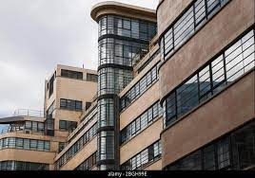
(source: https://www.alamy.com/art-deco-architecture-stone-glass-black-yellow-ibex-house-1-haydon-st-tower-london-ec3n-1hp-by-fuller-hall-foulsham-image354422631.html)
- Grade 2 listed in March 1982

3rd Stop: Daily Express Building, 120 Fleet Street
- Designed in 1932 by Ellis and Clark for the Daily Express newspaper
- Black façade with rounded corners in vitrolite (pigmented structural glass) and clear glass with chromium strips
- Flamboyant lobby includes silver and gilt decorations by artist Eric Aumonier that depict figures and symbols of the British Empire at its commercial peak, a silvered pendant lamp and oval staircase
- Grade 2 listed, not only for the architectural features but also the reinforced concrete stacked portal frame structure
- Refurbished in 2000 with recreation of the foyer
- Whilst it was occupied by the Daily Express, Private Eye referred to it as “Black Lubyanka”
- Was occupied by Goldman Sachs until 2019. In October 2021the City of London approved a re-development which will see a new tower wrapping around the building. The Daily Express building will be transformed into a publicly accessible cultural destination with social and educational reach, home to a free publicly accessible landscaped roof garden (press release City of London Corporation).
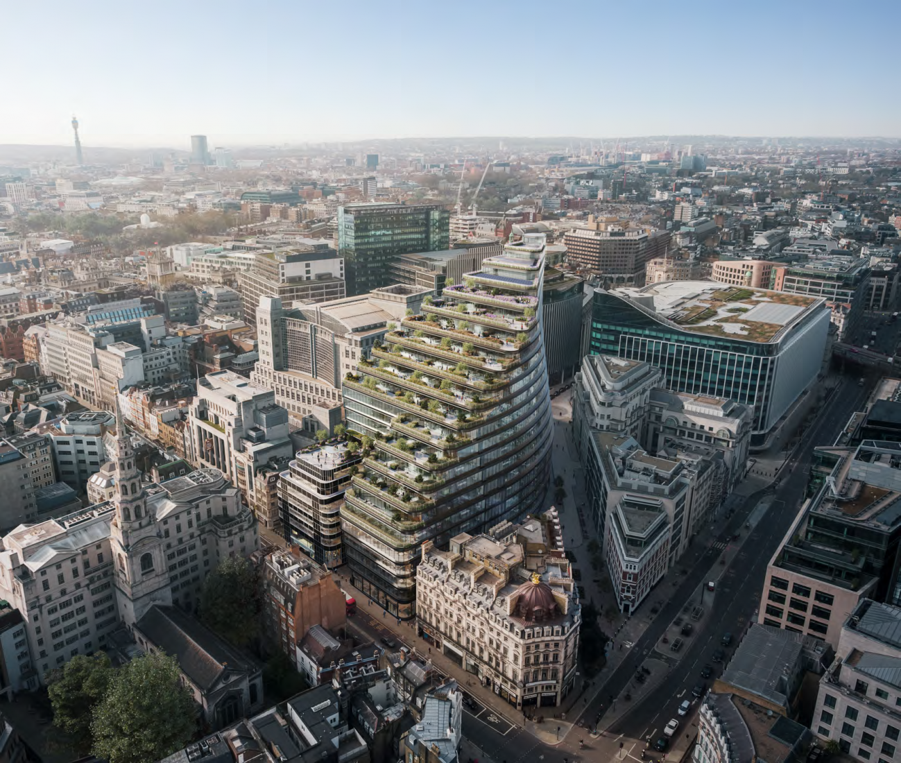
(source: https://www.architectsjournal.co.uk/news/big-gets-go-ahead-for-contentious-art-deco-style-office-block-in-fleet-street)

4th Stop: Daily Telegraph Building / Peterborough House, 141 Fleet Street
- Egyptian decorations and monumental colonnade façade
- Designed by Charles Ernest Elcock, after consulting with Thomas S. Tait (architect on Adelaide House) and opened in 1928
- Distinctive famous clock with its sunburst motives, chevrons and diamonds was added 2 years later
- Façade features combination of art deco and neoclassical details, large doric columns give sense of heritage
- Daily Telegraph moved out in 1980ies
- Grade 2 listed since 1983
- Also referred to as “Peterborough House” due to its being the former location of the Bishop of Peterborough’s inn - the DT newspaper had a “Peterborough” diary column until 2003
- The heads over entrance door (show picture) racing to deliver newspapers; top story features winged masks representing “The Past” and “The Future” and were carved in situ

5th Stop: Daimler Hire Garage, 7-11 Herbrand Street
- Designed by Wallis Gilbert and Partners who also designed the Hoover Factory and completed in 1931, again in Art Deco / Streamline Modern style
- Designed as headquarters for the Daimler Hire Car Company
- Building basement served as private car park with the upper storeys providing parking for the Daimler fleet, therefore the spiralling ramp
- Constructed of reinforced concrete, each floor has Crittal metal-framed windows in distinctive green which formed distinctive horizontal bands
- Piers between windows are set with horizontal channels, mirroring those in the windows
- Building became a taxi and bus garage with the London Taxi centre using the upper storeys and a coach company using the basement.
- Building now occupied by an advertising agency
- Grade 2 listing in 1982
- Planning approval in 2021 for internal transfigurement, and addition of floor at the side.

6th Stop: Senate House, Malet Street
- Constructed between 1932 and 1937 by Charles Holden who also prepared the interior design; he was famous for design of underground stations (South Wimbledon and several along the Northern Line from Clapham to Morden, interior of Piccadilly Circus)
- Originally intended to be part of a much larger structure where Senate House should have been just one of the towers
- At 19 floors it was the highest secular building in London when it was built
- During WW2 used by Ministry of Information; George Orwell’s wife worked there
- Grade 2 listed in 1969
- Often used in tv and films (Batman Begins, the Dark Knight Rises, The Theory of Everything, Dr Who, former film of 1984)

7th Stop: Royal Institute of British Architects, 66 Portland Place
- Opened in 1934
- Architect was George Grey Wornum – who had also worked on municipal buildings for Westminster Council, and was tasked with the coordination of the street decorations for the coronation of Edward VIII, which had to be modified for the coronation of King George IV and Queen Elizabeth
- Art Deco elements are bronze doors (each weighing 1.5 tons with a relief design depicting London’s river and its buildings), trans-storey main window
- Sculpted figures on the front show the spirit of man and woman as creative forces
- At the Weymouth street side, above the third story window line, are figures depicting a painter, sculptor, architect (Christopher Wren), engineer and working man
- Famous central stairwell
- Grade 2 listed in September 1970
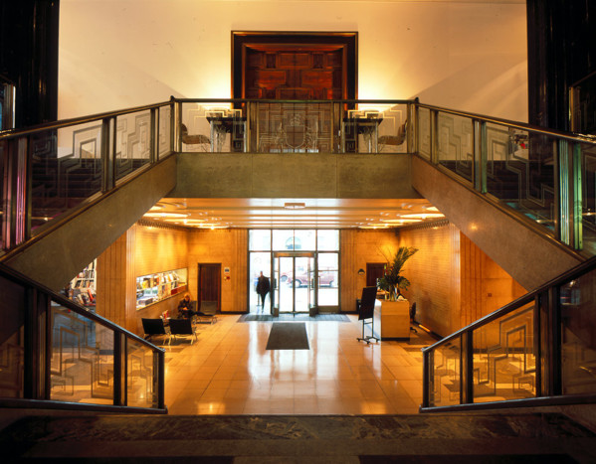
(source: https://www.ribapix.com/Royal-Institute-of-British-Architects-66-Portland-Place-London-the-entrance-hall-and-main-staircase_RIBA3184-44)

8th Stop: Broadcasting House, Portland Place
- Designed by G Val Myer
- Built with Portland stone, 9 floors above, 3 below ground
- Asymmetrical because local residents complained about the shadow the building would cast over houses in Langham Street
- BBC moved in in 1932, first radio broadcast 15 March 1932, also Grade 2 listed
- Interior lobby area also famous
- Herringbone elevator style doors, geometric pillars, modern lightening and classical statutes of Prospero and Ariel from Shakespear’s The Tempest: Prospero as magician and scholar sending out Ariel as the spirit of the air into the world). Sculptor Eric Gill had reportedly to reduce the size of Ariel’s genitalia; after his death his paedophilia/abuse became known.
- Extensive refurbishment in 2003 over several phases, finished in 2010; final cost > £1bn; addition of new wings etc.
- Interior design was marked by curved surfaces and neat flowing elegant lines
- 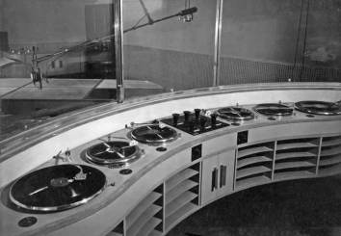

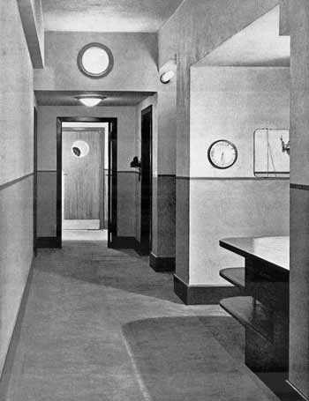
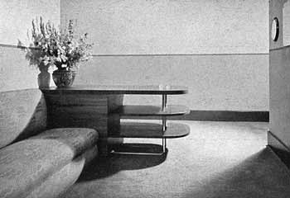

(photos source: https://artdecosociety.uk/2019/08/01/art-deco-at-the-b-b-c/)
9th Stop: Ideal House / Palladium House, 1-4 Argyll Street
- Designed by architects Raymond Hood (co-designed Chicago’s Tribune Tower, NY Rockefeller Center) and Gordon Jeeves (Earls Court Exhibition Center) as London headquarters of the National Radiator Company
- Black and golden exterior design was inspired by the American Radiator Building in Manhattan where Raymond Hood also was one of the architects. Black and gold were the colours of the National Radiator Company.
- Built in 1928-29, black granite facing decorated with inlaid enamel type decoration and Egyptian influences
- Top floor recess emphasises the gold stylised decorations
- Liberty opposite was built only 4 years earlier!
- Extended in 1935, thus the wider gap between 7th and 8th bay on Argyll Street frontage.
- In 1934 the British division of the National Radiator Company became “Ideal Boilers and Radiators” with the building being renamed “Ideal House”
- Today the name is “Palladium House” after its neighbouring Palladium Theatre
- Enamel door surround only now remains on Great Marlborough Street, the ones from the Argyll Street has been removed and is now in the V&A collection
- Grade 2 listed in 1981

10th Stop: Savoy Hotel, Strand
- Opened in 1889 as first luxury hotel
- First Art Deco elements were interior designs, starting with private dining rooms, then the gentlemen’s toilets by architect Howard Robertson
- In 1929 the iconic stainless steel Savoy sign was added by Howard Robertson who continued to design art deco interiors for the hotel for several decades
- The statue depicts Peter II, Count of Savoy (1203 – 1268) who had built the Savoy Palace in that area which had already been destroyed in 1381.
- Grade 2 listed in January 1981
- Restored for ca £220m in early 2000s
- Other hotels in Art Deco design are Claridge’s and Park Lane Hotel

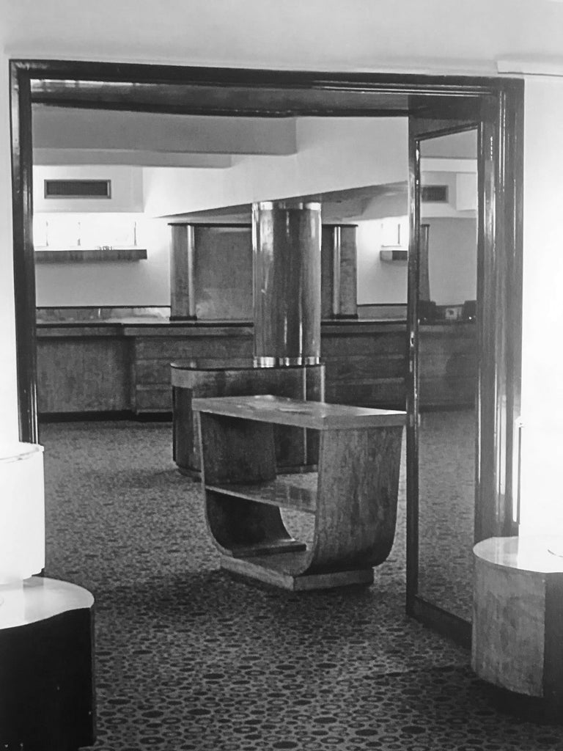

(source: https://shop.aghendy.com/products/savoy-hotel-art-deco-side-table)

Potential stop: Shell Mex House, Victoria Embankment
- In 1932 Royal Dutch Shell and British Petroleum merged to become Shell-Mex and BP – demerged again in 1976
- bold Modernist, Portland stone building, from 11 to 15 storeys high, with two basement levels. The river-facing façade’s upper storeys step inwards, and is crowned by a short tower with large clock face. The tower allowed the architect to circumvent the city’s height restrictions at the time, because the upper levels were for decoration, not for office space. Shell Mex and BP later extended upwards with a two-storey extension after height restrictions were relaxed following World War II.
- officially opened on 25 January 1933
- clock has a diameter of 7.62m (Big Ben 7m)
- used in WW2 by Ministry of Supply and Petroleum Board
- Grade 2 listed in 1987
- In March 2020, the owners were granted planning permission to refurbish the building, adding a new entrance pavilion. two-store conservatory in the courtyard and new roof terraces.

On way back over London Bridge look at Hay’s Wharf
- Named after company founder Alexander Hays who bought the site in 1651
- The wharf used to be where now the Hay’s Galleria is located
- Built as company headquarters between 1928 and 1921
- Architect: H.S. Goodhart-Rendel
- River Façade has panels designed by Frank Dobson called “Capital, Labour and Commerce!
- They show the frenetic scenes of dock life, with dockers loading heavy/luxury goods which are distributed into London

11th Stop: St Olaf House, Tooley Street
- Built between 1928 and 1932 by Harry Stuart Goodhart-Rendel as headquarters for Hay’s Wharf Company
- Built on the site of the demolished St Olave’s Church
- 39 terracotta panels designed by Frank Dobson who also designed the black and gold mosaic of Olaf II of Norway who helped protect London from the Danes in 1014 and an inscription about the former St Olave’s Church
- Staircase follows the linear design
- Bought in 1980s by London Bridge Hospital
- Grade 2 listed in 1971

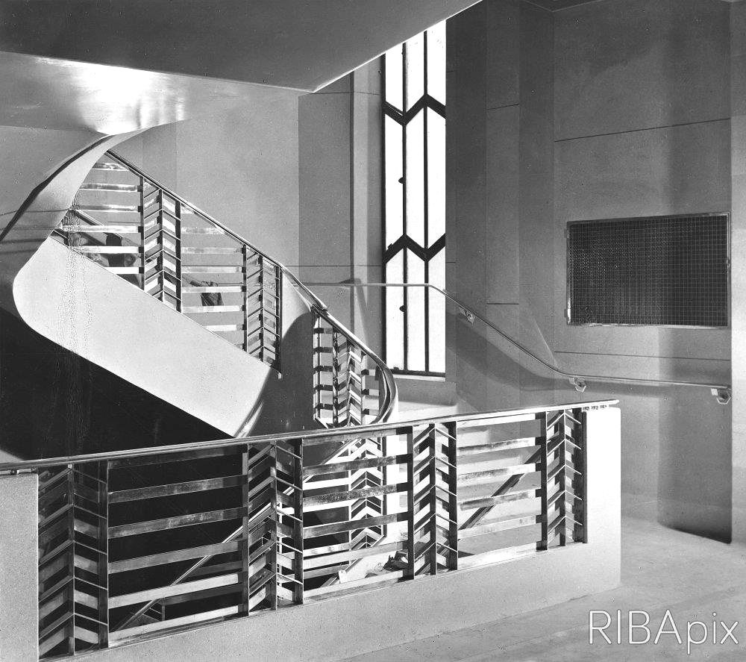

Source: https://modernism-in-metroland.tumblr.com/post/189474988336/staircase-st-olaf-house-hays-wharf-tooley

