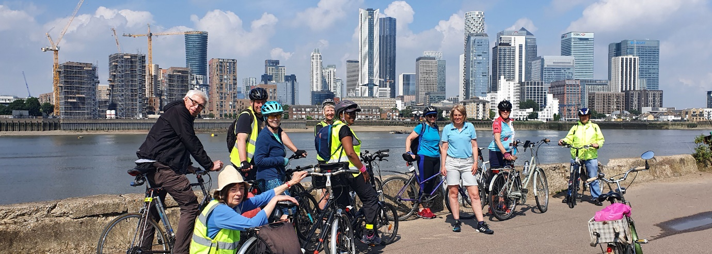
Annual Report on the Southwark Healthy Rides
Bruce Lynn, Healthy Rides Co-ordinator, Southwark Cyclists. 8 November 2021
Stats. 66 rides, average number of riders of 11. Compared with 59 rides with an average of 10 last year and 53 rides with an average of 17 in 2019.
Ride Leaders. 10 different people helped by leading rides or marshalling: David Senior, Simon Kenward, Jamie Pedrick, Philippa Goffe, Amanda Upton, Jean and John Sutton, Jane Champion, Vassilios “Bill” Moraitinis, Simon Saville. I am extremely grateful to them all. Southwark Cyclists could not offer such a terrific range of rides without their support. And these individuals do not just lead a ride for a few hours, they research the routes and often ride them several times to check them for safety.
Overview of 2021. This year, like most of last year, has been dominated by the pandemic. We started with a few rides in December, then we had the Christmas restrictions and a lockdown from January to March. In April we could restart rides under the “Road Map”. From mid April we have been able to run rides of 12-15 and have nearly always had 2 rides every Saturday. When all restrictions were removed in July LCC opted to continue to limit rides to 15. We have depended on Eventbrite for registering riders and in April switched to using the LCC account so that they have access to all our rider names and e-mails. The Facebook Group has gradually grown in use and now has 235 members (up from 147 this time last year). The Google group who have signed up for e-mails about rides now numbers 234 with only partial overlap with the Facebook Group.
We have had some great rides. Some are old favourites like the Royal Docks loop usually using the Woolwich Ferry, occasionally the Emirates Airline. We have done some new routes – Wimbledon Park from Dulwich for example. Themed rides are popular and this year we did a ride based on the London Tree Map and another to look at the best blossom. Occasonally rides take advantage of current events and this year we rode to marvel at the elephants and to assess The Mound.
Future. There continues to be demand for easy-paced, sociable rides like the Healthy Rides. Our rides are frequently fully booked and can have up to 10 on the Eventbrite wait list. Southwark Cyclists cannot meet this demand on its own. Would be helpful of we could persuade other LCC groups to organise similar programmes. There are similar rides in Bexley organised by one of our previous ride leaders. One thing that would help would be to train more ride leaders and I am trying to see if other groups and LCC are interested in organising a ride leaders course.
In summary. Another record year for the rides. The feedback we get from riders is great and those of us leading rides love getting the fan mail – it certainly helps to keep us motivated!

