Notes on Southwark Cyclists Healthy Ride 12/8/17
The Oldest House in the City

start - Canada Water Library, opposite Canada Water Station, SE16 7AR

Along Albion Channel
Rotherhithe street
Chambers wharf
Dock head
Tower bridge
Super HW (CS3)
Via St Dunstan in the East (Remains of a very old church that was bombed during WW2)
Q10
Barbican
41 Cloth Fair (Location of the cities oldest house)

Return -

West Smithfield
Farringdon road (CS6)
over Blackfriars bridge
picking up Q1 at Webber street and following until Stevenson Cresent
Southwark Park Road
Southwark Park
Surrey Quays
Canada Water

The route is 10.8 miles and pretty much flat. Track at www.mapmyride.com/workout/2252218598

St Dunstan of the East
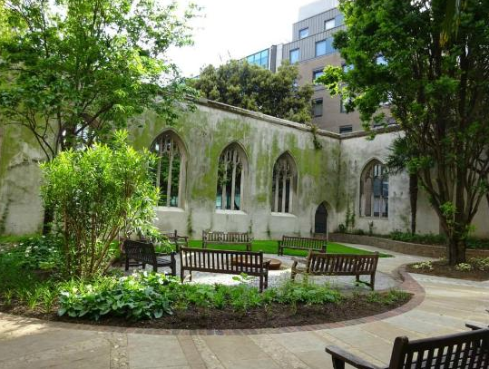
The church was originally built in about 1100. A new south aisle was added in 1391 and the church was repaired in 1631 at a cost of more than £2,400.
It was severely damaged in the Great Fire of London in 1666. Rather than being completely rebuilt, the damaged church was patched up between 1668 and 1671.A steeple was added in 1695–1701 to the designs of Sir Christopher Wren.
The church was severely damaged in the Blitz of 1941. Wren's tower and steeple survived the bombs' impact.

The Oldest House in the City - 41 Fair Cloth - Built in 1597
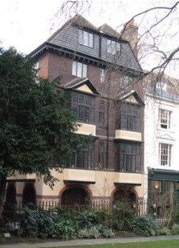
Hidden down a small street in Farringdon lies a quite remarkable building – 41/42 Cloth Fair. Built between 1597 and 1614, this is the only house in the City of London to have survived the Great Fire of London in 1666.
Records tell us that the reason it escaped the brunt of the fire was due to it being enclosed within a large set of priory walls. Records also show that the building was originally part of a larger scheme of eleven houses featuring a courtyard in the middle, known as "The Square in Launders Green".
Some interesting facts about the house:
• A set of leaded windows within the property bear the signatures (etched with a diamond pen) of some rather famous visitors; Sir Winston Churchill and the Queen Mother to name just two!

Notes by Harry Clark, Ride Leader

