Southwark, Lambeth and Wandsworth

Design Report Elephant and Castle   
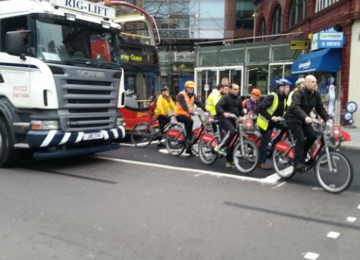

# Updates

|  |  |
| --- | --- |
| Date | Author/Version |
| 8/12/2015 | v0.2is Francis Bernstein – draft sent to TfL and group to support on site LCC meeting following TfL and Police cycle ride of 7th December |
| 10/12/2015 | v0.3 DRAFT |
|  |  |
|  |  |
|  |  |
|  |  |
|  |  |
|  |  |
|  |  |

Introduction

The objective of the exercise is to; on a regular basis cycle through new highways and cycle schemes during build and ensure where possible that the traffic management implemented does not negatively impact on vulnerable road users. Design/sponsor observations seen during the installation phases are raised in this report.

# Minutes

| **Issue** | **Incidents occurring, or likely, as a result of a problem** | **Actions/Responses** |
| --- | --- | --- |
| **Elephant & Castle** |  |  |
|  | **Exit towards St Georges**  ASL requested to be considered.  Poor sighting of TM signals. Secondary signal suggested.  Poor TM lane markings with drivers seen getting stuck driving in bus lane.  Poor advance “direction” signage  Why no “No Entry” at junction. Risk in light traffic for vehicles to attempt U-Turn or a mistaken turn.  Suggest major revised junctions need more supportive signage and signals. |  |
|  | Is TM optimal to reduce “left hook” risk from lorries? |  |
|  | **Entry from London Road:**  Increased congestion in London Road, combined with no yellow box (or Keep Clear), means cycle crossing regularly being blocked.  Can new phasing or other measures be considered? |  |
|  | Poor advance “direction” signage.  Can this additionally be placed more clearly to inform drivers?  Overhead gantry? |  |
| cid:image003.jpg@01D131FD.B3C368F0 | Wider ASL requested to be considered.  Significant bus, coach and lorry congestion mean may cyclists, P2W arrive at junction in offside location. |  |
|  | **Issue raised due to immediate safety concerns.** There are three lanes, nearside is directed with “left” arrow (towards OKR) and two towards Kennington, with “straight” arrow.  PM peak many vehicles and most coaches turning “left” from middle and offside lane, creating significant “left” hook risk. Many left turning buses impacted by offside traffic turning left.  Offside traffic slower to clear, and blocking pedestrian crossing with “green man”.  Many P2W seen to accelerate fast off green signal from the offside lane to turn left. |  |
|  | Emergency vehicles regularly seen using opposite carriage. Similar reports of segregated wide cycle tracks being used in other areas. To be monitored. |  |
| cid:image006.jpg@01D131FC.BBCEB1E0  Red arrow, bus and cyclist with green signal exiting London Road with traffic still flowing across junction. | **Exit into London Road (from OKR)**  Depth of junction, coupled with phasing and congestion, vehicles regularly trapped in “no man’s land” blocking crossing. As no waiting area, vehicles cross into London Road at the same time there’s a green signal from London Road into the junction. |  |
| cid:image006.jpg@01D1321C.5E125D70 | **Exit towards Newington Butts**  TM road white road edge markings recommended on corner.  Pinch point for cyclists on corner. Suggest nearside cycle lane is marked. Slower and wider (e.g disability cyclists) at greater risk.  TM risk of plant equipment creating a blind corner. |  |