London Bridge Area: How to create the best people environment post station redevelopment
A report from Southwark Cyclists
Overview
Recent work commissioned by Team London Bridge has looked at how the street environment around the redeveloped London Bridge Station might be improved. Tooley St and St Thomas St are the key streets. The report argues for better facilities for pedestrians and cyclists, with less space for motor traffic. From a cyclist’s perspective this all sounds good. However, the detail is not always good and there is much too much emphasis on one-way streets. So what comes next? The report envisages a “Stage 2” for “a more detailed Feasibility Design Study”. This will involve Southwark Council and TfL. There is a real challenge for these bodies. It would be possible to create a superb street environment around the station and linking through to the Thames waterfront. But only if motor traffic is substantially reduced. It will require real leadership at a political level to achieve this and to create something special in the wake of the station redevelopment.
Outline
- Summary and comments on the Report: London Bridge Connectivity by Jacobs for Team London, May 2015
- Discussion of what this report does not cover
- Stage 2 – what needs to be done next

Summary of the report

Aim of report was “Optioneering and Concept Design Study, which identifies baseline conditions, issues and opportunities, develops the connectivity strategy for the London Bridge area and produces (assumed up to 5 combinations of) broad options for further detailed review”
“The main focus and hence the ‘core’ area of study is Tooley Street and St Thomas Street but where proposals for these roads impact the wider area or where existing proposals in the wider area impact on the core are then these are taken into account.”
“The stage 1 work has developed a set of options for changes to the current highway layouts which may be put in place after the current station works are completed to improve the streetscape for all users of the area.”
“We have benefitted from assistance from key Transport stakeholders including Network Rail and TfL as well as getting inputs from key land owners in the study area.”

Series of maps of cycle parking, bus stops and collisions. No numbers are provided which is unhelpful.
The report looked at 8 junctions (actually 6 junctions and 2 crossings).

- Borough High Street/Southwark Street
- St Thomas Street/Borough High Street
- Borough High Street/London Bridge Street
- Borough High Street/Duke Street
- Tooley Street (crossing at London Bridge Station exit, bottom Duke St Hill)
- Tooley Street (crossing near Hays Lane)
- Tooley Street/Bermondsey Street
- Bermondsey Street/St Thomas St

These were observed on Thurs 12 March 2015 at am and pm peak. Level of Service (LoS) assessed on scale A-D. A, B is free movement, C reaching capacity, D over capacity. None D. 2/8 C at am peak, 6/8 C at am peak.

Section 3 has maps of major servicing points and car parks, % saturation at 10 junctions – different set to those assessed above, but some overlap. The maps are unreadable as very low resolution. They are probably copied from a planning application as report says much data was trawled from recent planning applications, particularly those for London Bridge Station redevelopment. Other maps show traffic movements planned for Tooley St 2016-18 part closure, plus a map of am peak hour station passenger exits and numbers using crossings at am peak. These numbers are just readable. Coloured lines showing main pedestrian desire lines are provided, with no explanation of what different colours mean. There are incomprehensible maps of bus routes.

There is a long section listing comments from consultations. Some are quite interesting:
- “Tooley Street is a barrier to movement, need to remove this and improve links across it.”
- “It is seen as a key Bus/Pedestrian/cycle corridor. There should be less emphasis on cars and especially through traffic”
- “TfL is currently in the process of meeting and consulting with Boroughs to understand the typology of streets with relation to the Roads Task Force (RTF).” [This is interesting as at present these roads are part of the Strategic Road Network of “Red Routes”. As pointed out below, this has to change or we will get nowhere, so fact that road classification is being discussed is hopeful.]
- “Note that the station currently handles 54 million passengers per annum. This is likely to grow to 100m in the future”

The next section sets “Strategic Options”. First a diagram shows 9 tiny maps with arrows along various roads. It is hard to follow what is going on. Then there are a quite interesting series of diagrams of detailed street changes, e.g. schemes for turning circles if roads are closed to through motor traffic.

Section 5 of the report then sets out “Options for further assessment”

- Option 1 is to return to situation before the work on London Bridge, hopefully not in practice an option.
- Option 2. Tooley St 2-way. St Thomas St west part one way east and east part one way west. Both feed into Weston St one way southbound then disperse through surrounding roads.
- Option 3. St Thomas as was, i.e. 2 way at western end but one way westbound for eastern part. Weston St connected and 2 way. Changes here are on Tooley St. Eastern part one way eastbound plus buses allowed westbound. So much as now in effect as little traffic can enter eastern end. Western part one way west bound with a bus contraflow. So this is quite like the plan for 2016-18 during the building work on London Bridge Station. Will reduce through general traffic on Tooley Street but put a lot of traffic on the Bermondsey St through the tunnel (one way north as now).
- Option 4. This is interesting. It is proposed to take a short stretch of Tooley St just west of Bermondsey St and make it bus only. Both east and west legs will be 2-way. Turning circles for local delivery traffic will be created at each end of the bus only segment. This is modal filtered permeability (although not called that). Presumably pedestrians and bicycles can permeate. So this is finally something we can support wholeheartedly. Bermondsey street tunnel will become very low traffic on this scheme as this traffic can only access the west half of Tooley St. As this can be more easily reached from Tower Bridge Rd, will lead to few vehicles opting to use the tunnel. This option keeps St Thomas 2 way west part, 1 way westbound for east part.
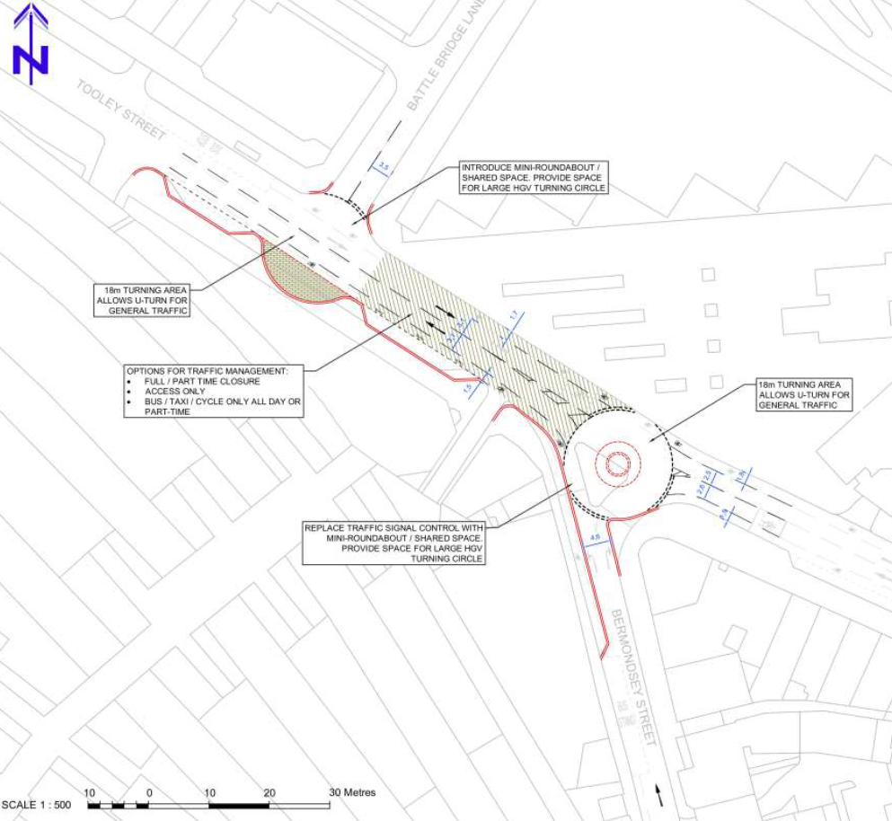

- Detail of how modal filter could work on Tooley St. (from Jacobs Report)

- Option 5 is a combination of options 2 and 3. It also includes “shared surface” for the west parts of Tooley St and St Thomas St. Shared surface is where there are no separately kerbed areas, e.g. pavements. Pedestrians, cyclists and motor transport share the same space. An example is Exhibition Road. As in Exhibition Rd, there clearly has to be some designation of where motor vehicles go. Team London Bridge published some concept pictures in December 2014 (see http://www.london-se1.co.uk/news/view/7990) showing how Tooley St might look.

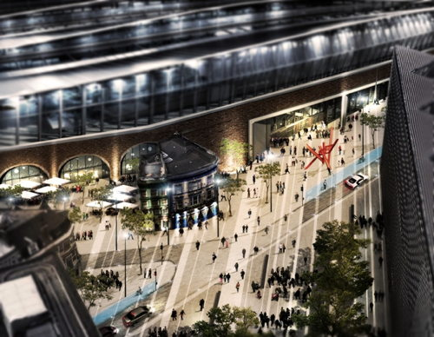
This picture does not match exactly the proposal in Option 5. It is the junction of Tooley St and Bermondsey St with the new station entrance upper right. Note the planned cycle superhighway (CS4) is shown as a blue track.

We have some further points from the options;
- the south part of Bermondsey St from Tanner St to Long Lane is marked as “Pedestrian Only” on the maps of all the options
- traffic is shown going west along Newcomen St, something that is planned to stop when the Jubilee Quietway is delivered.

The report proposes a Stage 2 – Detailed Feasibility Study. They note:”TfL have identified that post 2016, the Tower Bridge to Westminster (south of River) route is a strategically important one and that TfL needs to be mindful of the impacts of any schemes that affect traffic flows in the area.”

What the Jacobs Report does not cover.
- The brief is too limited. You cannot look at Tooley St and St Thomas St without addressing the wider issues related to traffic along the south of the Thames corridor. And to do this you have to look at a lot more than the local streets.
- There is no discussion of what makes a good cycling and pedestrian environment. There is a fixation with one way streets, but these create the worst pedestrian/cyclist environment. Traffic travels further at higher speeds. More risk of collision; more pollution; more noise. We should be aiming to create short routes on slow streets, i.e. getting back to 2-way working with as few restrictions on turns as possible.
- There is no attempt to incorporate existing cycle plans except CS4. The Jubilee Quietway and other components of the Central Grid (Bermondsey St tunnel contraflow, for example) are not mentioned.
- There are no numbers! Jacobs seem not to have done any traffic counts, or even bothered to collect up the available data, e.g. from Department of Transport Average Daily Flow statistics. Most notably, they have not investigated how much of the traffic on Tooley St and other local streets is starting or finishing in the area and how much is passing through. This is critical to thinking about solutions such as the excellent option 4.

What needs to be done next – i.e. what should Stage 2 do?
Jacobs’ report correctly identifies the issue of how TfL views Tooley St and St Thomas St. At present they are part of the “Red Routes”
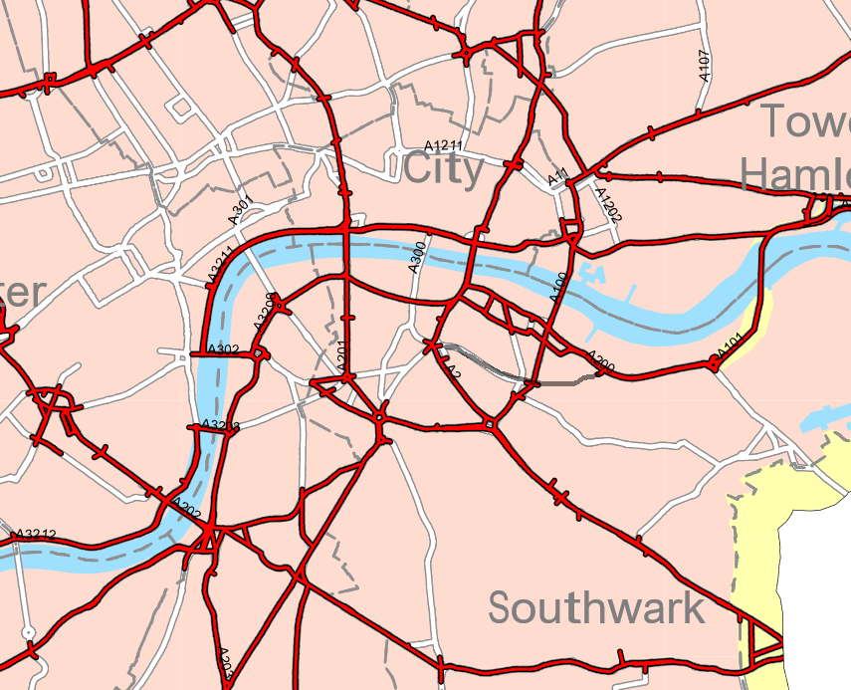

Red routes in London Bridge and surrounding areas. An alternative E-W route using Long Lane and Abbey St is marked in grey. https://tfl.gov.uk/modes/driving/red-routes/red-route-maps

Note that Tooley St, St Thomas St, Bermondsey St Tunnel and Weston St are all still marked on the red routes map on the TfL web site (2 Oct 15). I presume TfL know that Weston St has gone! But are they prepared to re-classify the other roads? There are alternatives. And because the Thames turns south, these are just as direct. In fact the most direct route from the A200 and the Rotherhithe Tunnel to Westminster is via Abbey St, the Borough and St Georges Circus (partly marked on the map above). Another route from Tower Bridge to Westminster is via Bricklayers Arms. Or if you want to reach the Victoria area, stay on the ring road from Tower Bridge and avoid the congestion charge. These alternatives look adequate and the Report indicates that TfL will model traffic over the wider area to check.

To create a world class public domain linking the station to the waterfront and to all the high use destinations requires Tooley St and the west part of St Thomas St to become just local feeder roads with no through traffic. And remember that as well as existing attractions like Tower Bridge, HMS Belfast, the Galleria and the Shard, plus important public buildings like City Hall and the Southwark Council Offices and the 2 hospitals, another hotel is being built at 1 Tower Bridge, the Kings Science Gallery is planned for St Thomas St, Southwark Theatre is returning and a new 1100 seat theatre is planned for 1 Tower Bridge. Pedestrian numbers are going to rise. Plus the push for more cycling following the Mayor’s “Cycling Vision”, to improve health, reduce pollution, and take some of the pressure off public transport.

Within the London Bridge area as a whole, pedestrian and cycle density is high throughout. However, it is relatively less so along St Thomas St in its eastern half. So this segment could have more motor traffic. In looking at this, it is important to examine all traffic patterns within the “cell” bounded by Tower Br Rd, Long Lane, Borough High St and the railway. This is an area with lots of housing, lots of small businesses, and a major hospital. There should be no through routes in this area. Businesses and homes can be linked to the surrounding through routes by local roads that are filtered where appropriate to stop through traffic, whilst allowing free pedestrian and cycle movement. This sort of strategy has encouraged increases in cycling and walking, and improved the overall street environment, in areas of Hackney and in Cambridge. It is interesting that a segment of Bermondsey St at the south end of the cell is labelled as “pedestrian only” on the planning maps in the report. The plan for closing Newcomen Street to through motor traffic is consistent with this sort of development. But we badly need and overall scheme that provides good access for local residents and businesses and to the hospital, while eliminating fast through traffic.

It is also very important to make sure that junctions work efficiently for pedestrians and cyclists. Even with reduced traffic and 20 mph, some junctions will remain slow for pedestrians and dangerous for cyclists (remember most collisions occur at junctions). The major junctions (Tooley St/Tower Br Rd; Duke St Hill/London Bridge) need particular care in their design. And there must be a pedestrian crossing at the Queen Elizabeth St/Tower Bridge Approach junction.

In summary Stage 2 needs to:
- Develop an overall plan for traffic flows in not just Tooley and St Thomas Streets, but all the streets immediately south, at least as far as Long Lane.
- Collect data on the proportion of traffic on Tooley St that is not locally terminating or originating. With this data the effect of blocking or restricting through traffic while allowing local traffic can be assessed.
- As stated in the report, do modelling of alternative routes south of the Thames to optimise traffic flows when Tooley St and St Thomas’ St carry much less through traffic.
- And finally, as stated in the report, come up with an agreed plan for creating a people-friendly environment in the London Bridge area

Bruce Lynn
Southwark Cyclists / London Cycling Campaign Infrastructure Group
10 October 2015

