Southwark, Lambeth and Wandsworth Review TM 15th and 16th July 2015 Spot Checks
Author: Francis Bernstein

Cycled Area

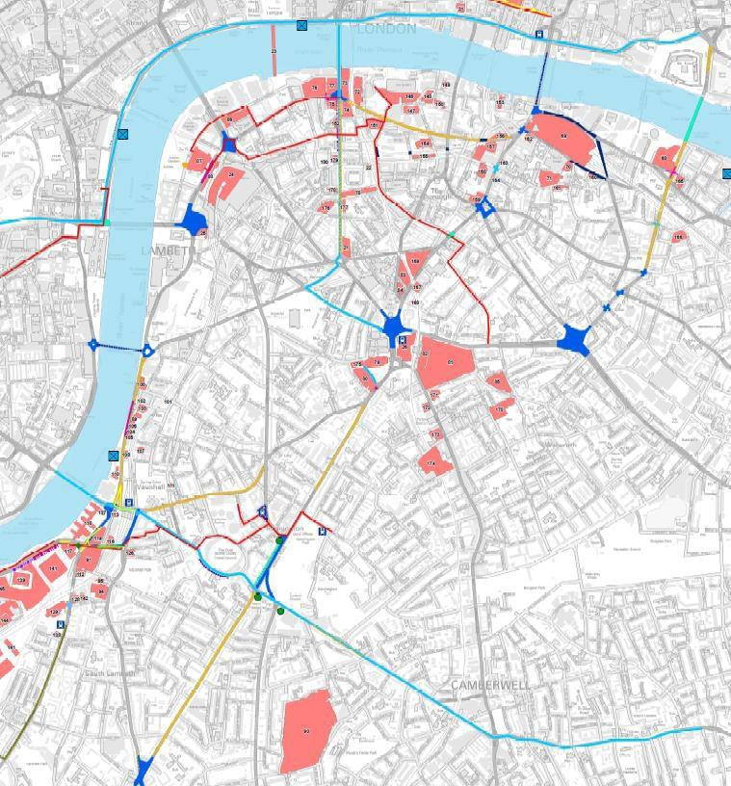

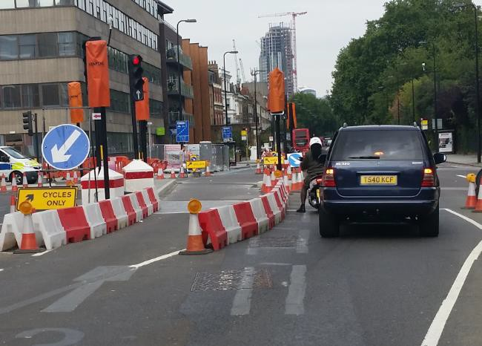
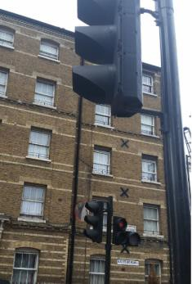
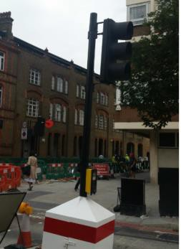
Notes

Item | Ride Comments | Actions
Review of Oval TM 16th July 2015
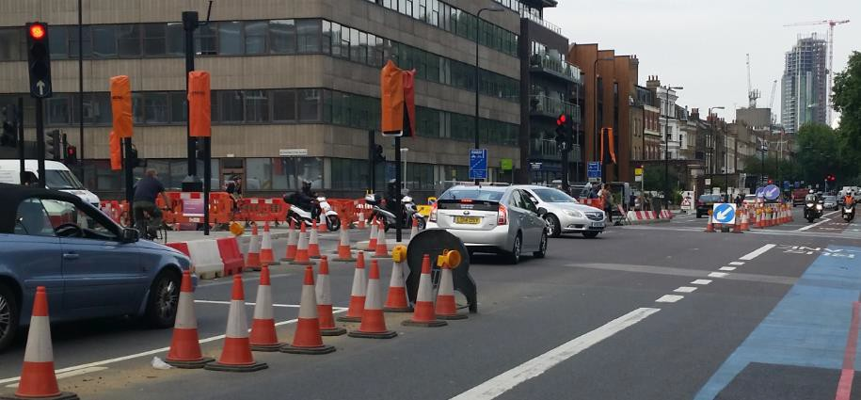  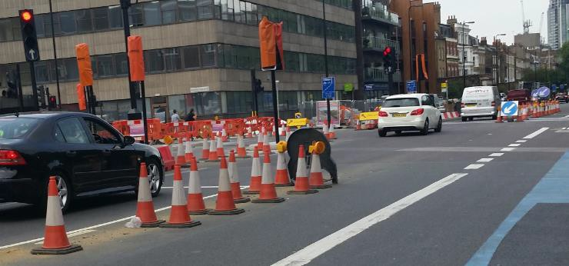 | Potential for severe vehicle to vehicle side on impact high. Two near misses seen in 15minutes. Poor visibly of traffic signal considered primary cause.  Following layout TM changes, there is no traffic signal close by the general traffic lane stop line. Kennington Park Road junction (with Kennington Road).  There is no offside traffic signal by the stop line.  There is only one working traffic signal on far nearside of cycle lane (angled at 45deg towards offside lane) and not always spotted by all drivers and P2W. This signal is set back from stop line and is considered a confusing layout.  The signals on the opposite side of junction cannot always be seen on approach by drivers due to other TM/highway obstacles and the offset road layout (see photo).  Drivers seen to drive over the "red" phase (to E&C) into direct path of traffic from Kennington Road.  Van and other drivers seen to tell gate on “red” phase (if it was seen). | Urgent attention to ensure review of safety at junction and visibility of traffic signals.  On complex junctions, with offset lanes, traffic signals need to be seen clearly on approach and in front of the stop line.
Review of Blackfriars Road TM 16th July 2015
 | Northbound.  Location of stop line for cyclists too far forward so cyclists cannot see aspect on TM signals if stopped at lights. Impacts signals on both sides of traffic lane. | Locate stop line, so cyclists can see signal aspects.

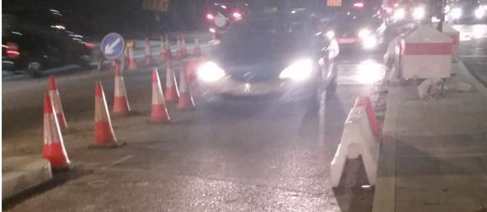
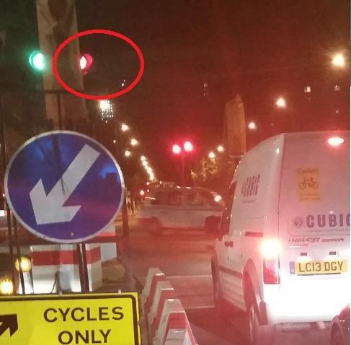
Review of Oval TM 15th July 2015
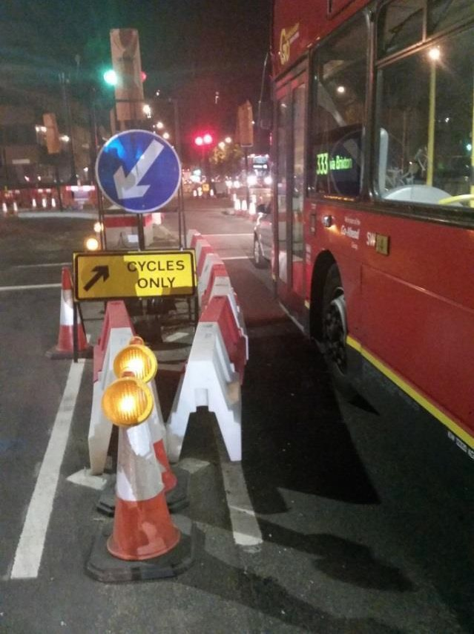 | Is this “cycles only” sign meant to be here? Unclear cycle safety signage for narrow lane. Could there be temporary speed reduction?  Previous TM at location:  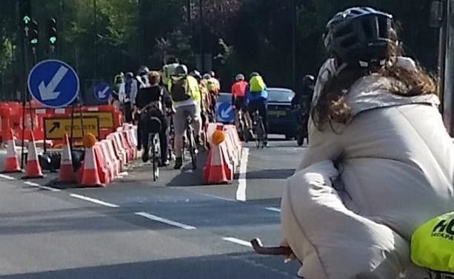  Why are two bollards left at narrowest section? If meant to be deterring pedestrians, why not leave on the pavement?
Why is there only one traffic light?

Single signal is poorly located to the left of the stop line, and poorly visible for straight ahead traffic.

Item | Ride Comments | Actions
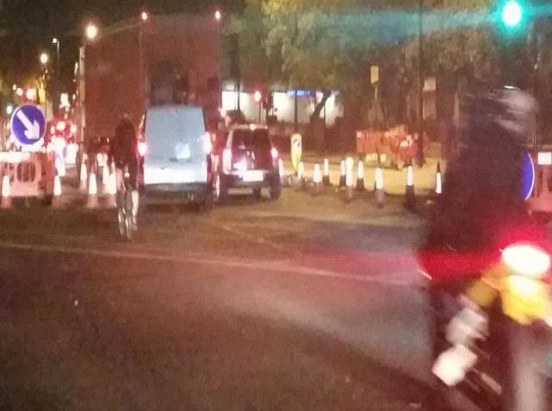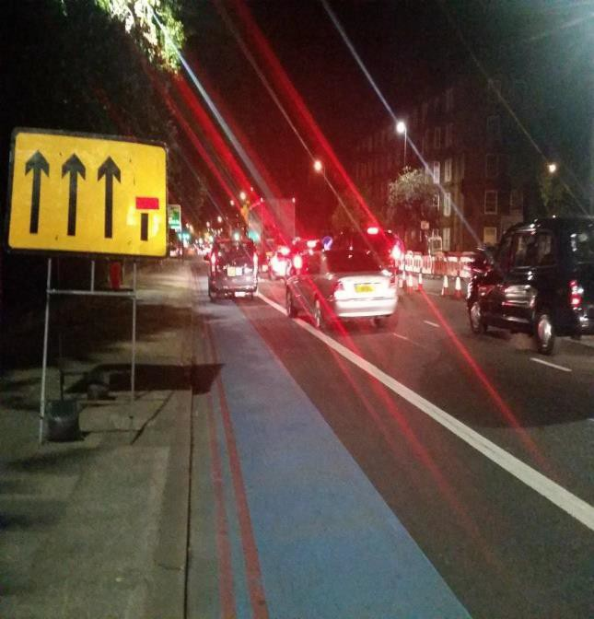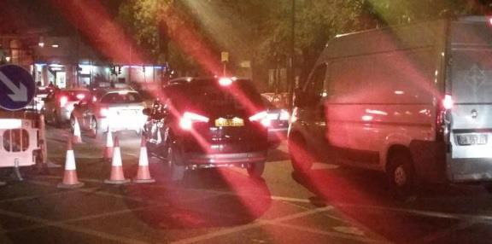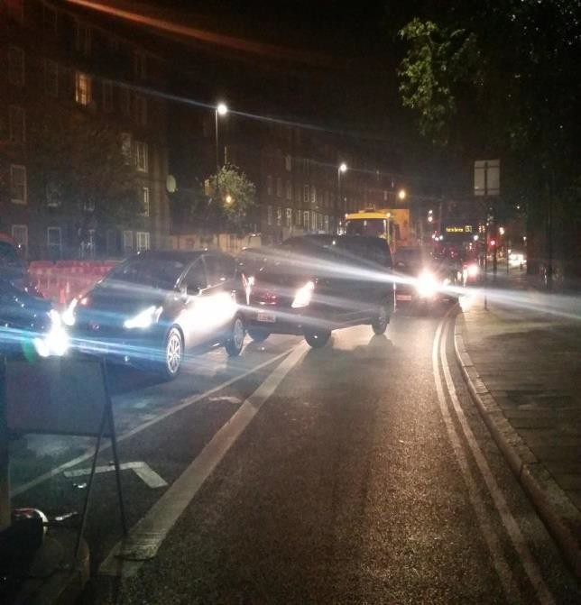 | TM sign is confusing. The nearside lane is not “ahead only” and is left filter lane at the junction. General traffic is only 2 lanes to go ahead (on approach to the junction).  At the junction, the highway narrows to two narrow general lanes. Many nearside drivers confused and causing sudden/abrupt lane changes at junction.  Cyclists and P2W trapped crossing over the junction.  Abrupt lane pinch points on leaving a junction are not recommended . | To be reviewed and TM signage improved.

