Southwark, Lambeth and Wandsworth

Cycling and Traffic Management Partnership – 2 July 2015

Author: Michael Barratt TfL, Charlie Holland and Francis Bernstein Southwark Cyclists Planned Interventions, Road Space Management Directorate, Transport for London

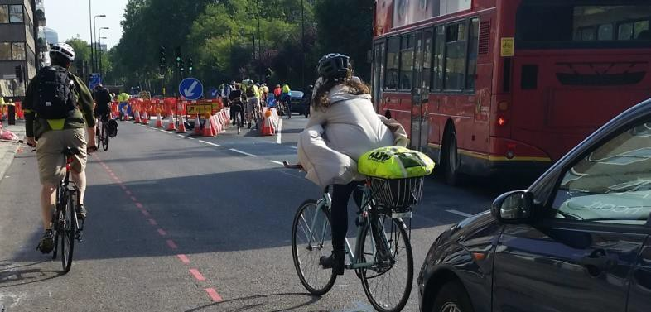

Attendees

Andy Cawdell | Southwark Cyclists
Charlie Holland | Lambeth Cyclists
Ivan Martinez | Sustrans
Kelly Clark | Sustrans
Rajiv Ratan | Sustrans
Michael Barratt | TfL Planned Interventions

Cycled Area

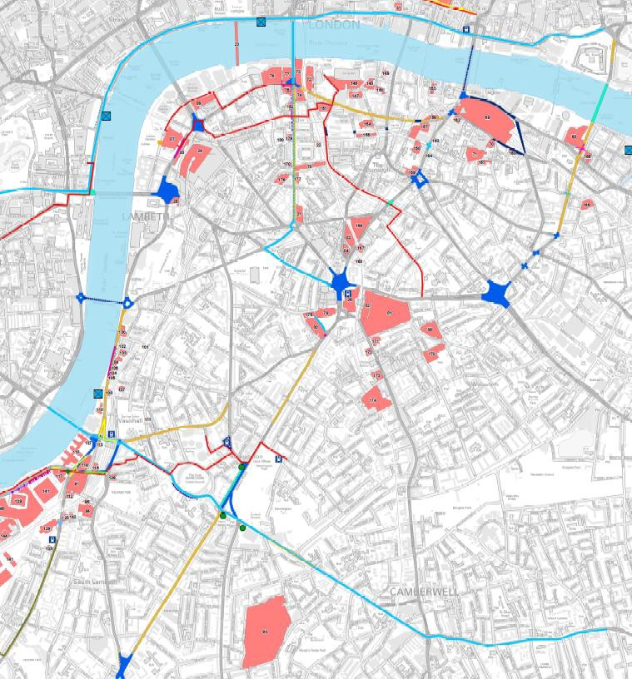

Minutes

Item | Ride Comments | Actions
Introduction

The partnership is made up of TfL, Southwark and Lambeth cycle groups.

The objective of the exercise is to; on a regular basis cycle through TfL schemes during build and ensure where possible that the traffic management implemented does not negatively impact on vulnerable road users.
Cycle Superhighway 5
1  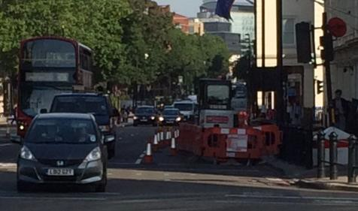 | Vauxhall Bridge Rd  This highway carries substantive lorry and heavy traffic, yet bollards creating a long pinch point. Cyclists observed to be cycling within TM to avoid conflict  Outstanding issue | Can lane 2 width be checked and possibly relocate traffic cones to accommodate a 1.5m cycle space for South bound cyclists.
2.  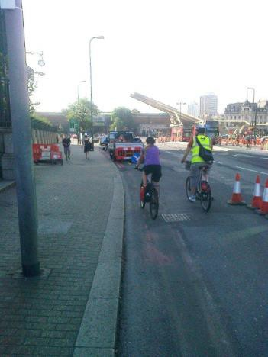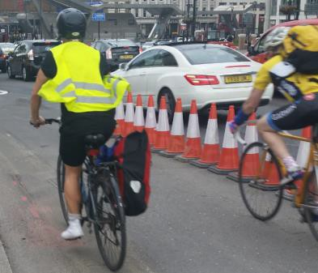  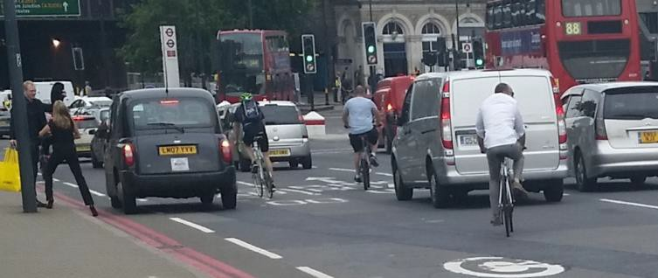 | Vauxhall Bridge  Contractor Vehicles blocking safe progression of cyclists once leaving the segregated section south bound.  Utility contractor surrounded the vehicle with traffic management and left the scene.  Many cyclists at fast speeds after long downhill over the bridge.  The (temporary) extra-wide cycle lane adds to this speed risk where some cyclists then need to merge into faster flowing traffic to get into the appropriate late. | Monitor site for obstructions in this section and ensure vehicles do not park unnecessarily.  MB to report to permitting team

Item | Ride Comments | Actions
3.  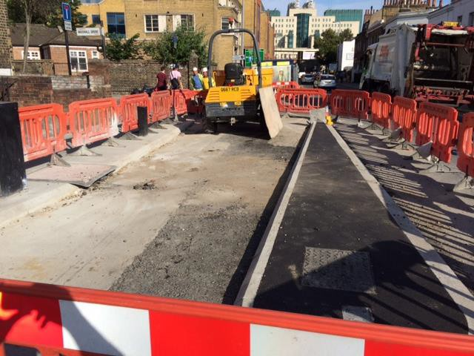  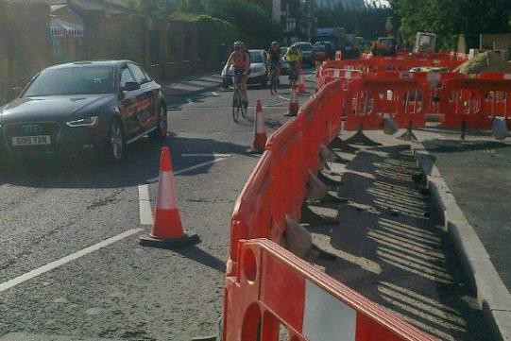 | Harleyford Road  Question for TfL – the deflection seems to put cyclists towards the carriageway opening. Is this correct?  How wide will CSH be inside floating bus stop? It looks as though it may be quite a squeeze for two-way cycling. Will footway users have sufficient space - a need to cut back plant growth in June going forward?  Harleyford Rd - could the TM be used to provide a lane for people cycling? | TfL design team to confirm island layout is correct
4.  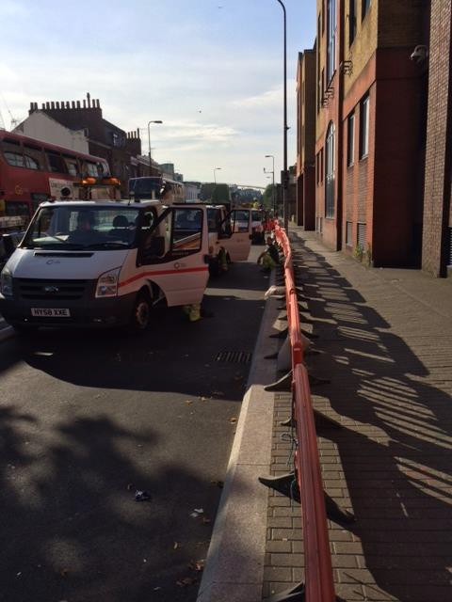 | Harleyford Rd  We observed a lot of vans in the segregated cycle lane. Is there a requirement for so many as this could be given to cyclists to avoid conflicts? | AL to confirm reasons. Are they all bringing materials or staff?  Can a mini bus be used instead?
5. | Harleyford Rd  Floating bus stop taking out cycle lane width.  What concerns were raised with regards to conflict? | AL to confirm dimensions
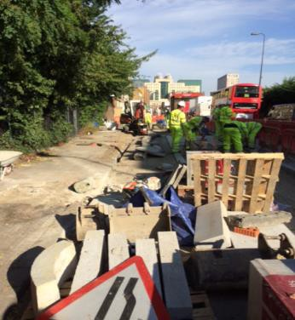
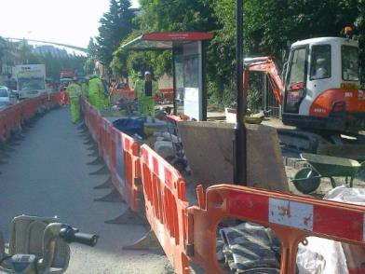

Item | Ride Comments | Actions
Northern Line Extension- Kennington Rd
6. | Various tweaks over the last few months to ensure TM meets cycling standards.  During the evening peak especially, cyclists have been riding at speed along the footways coming into conflicts with pedestrians.  This has raised complaints. Various options to combat this were discussed.  People cycling keeping to the left. Would central 1057s encourage a more centre of lane riding position here?  If enforcement action is taken against people riding on the pavement, it needs to target reckless people. First requirement though is to try all possible ways to get an attractive cycling option going southbound. | MB to meet local MP and local residents to discuss issues and what TfL propose to mitigate  SH to supply TM for all phases to see how tweaks can be done
7. | Interim methods to assist with issues:  - Put barriers on footway  - Marshals to express need to dismount or use road  - Remove broken down dumper to give more space  Possible options:  - Tidal arrangement (Rajiv)  - Maintain a southbound cycle facility | MB to chase SH for updates  MB to explore all options especially a tidal arrangement idea supplied by RR
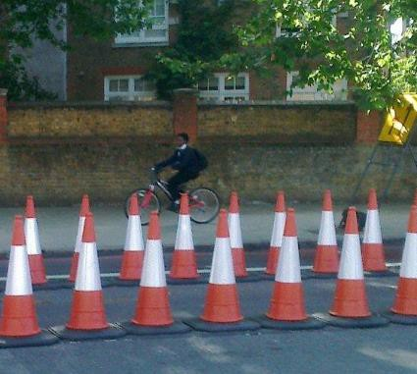
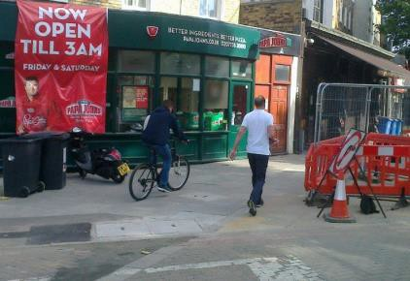
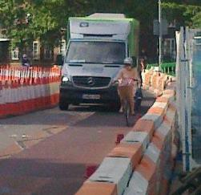
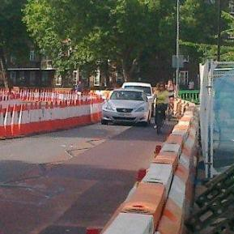
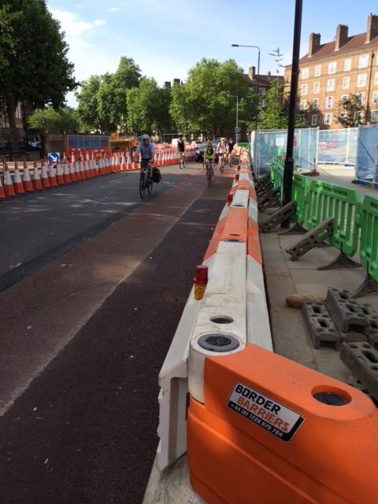

Item | Ride Comments | Actions
Oval Better Junction
8.  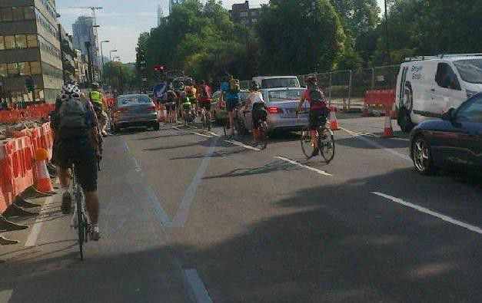  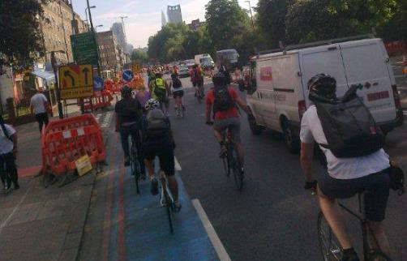  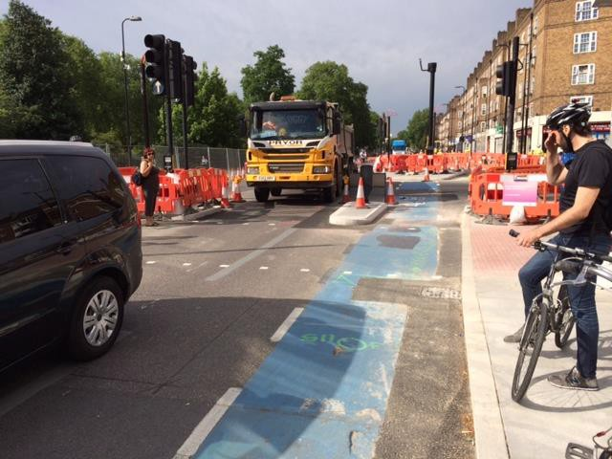 | Kennington Park Road (KPR)  Due to Thames Water burst pipe, KPR is down to one lane in both directions with less than desirable cycling facilities. This is out of the hands of the PM until the road is returned.  Some cyclists observed to use new segregated area only to be re diverted back onto main flow.  Cycle volumes very high.  At peak times, cycle volumes exceed safe segregated areas, leaving cyclists queuing vulnerable with fast flowing nearside traffic with lorries and buses. | MB to discuss with WCaP re alignment of water filled barriers north of the junction with Kennington Rd.  This could be changed to accommodate cyclists and remove potential conflict.

Item | Ride Comments | Actions
Cycle Superhighway – N.S
9.  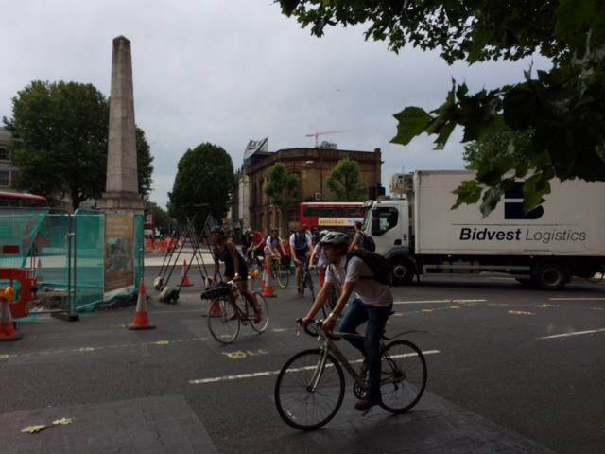  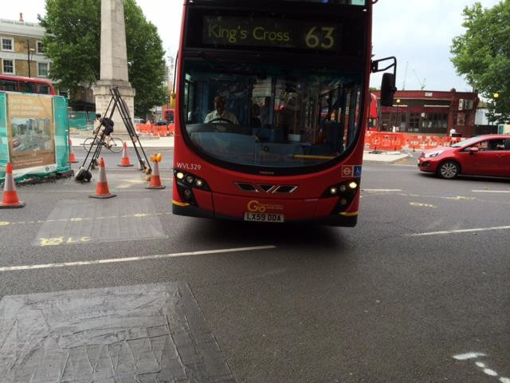 | St Georges Roundabout  The TM on the exit from London Rd to Blackfriars Rd Causes an uncomfortable maneouvre for both buses and cycles navigating the roundabout.  Vehicles are also observed to constantly block vehicle from crossing | MB tweaked TM to minimize this obstruction.  PS to monitor and tighten up where possible  Suggestions for “keep clear” road markings to help issue. This could be done by using white adhesive tape to avoid carriageway damage

Item | Ride Comments | Actions
10.  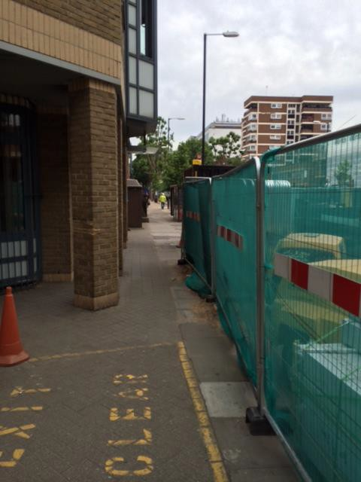 | Blackfriars Road  Pedestrian concern: Section 17 crime and disorder act. This area is highlighted as potentially unsafe to peds as there are numerous ambush points and no visual extra lighting supplied. | PS to source lighting and block up areas of potential ambush points.
General Comments
11. | The cycle phase from Lambeth Bridge roundabout south side which helps access the bridge needs to be investigated.  When the green came on two vehicles still came passed. This could have been by jumping the lights or a phasing concern. | Mike Bloomfield to be consulted.
12.  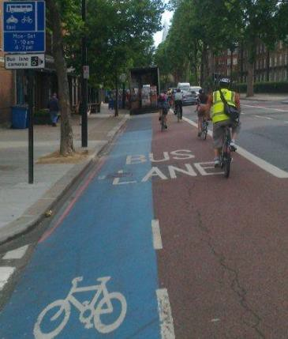 | A Tesco delivery lorry unloading at 08.52 in the cycle/bus lane on Kennington Pk Rd - a common occurrence. | Improved enforcement on cycle sensitive routes.
14  TM signage of superhighways suspension | Can we use Princess Street as pilot for a standardised approach? | MB to discuss with Parminder.  PS to update

Item | Ride Comments | Actions
15.  Forward schedule of change | A forward schedule of change over TfL PM delivery teams, to ensure cycle monitoring can be scheduled for key upcoming TM changes.  Outstanding issue | Standardised reporting across delivery teams for major TM changes or review points.
16.  Future Meetings | Date and Location of Next Meeting: | MB to send meeting invite

