Elephant and Castle – Making it safe for cyclists and pedestrians

Summary of Key Points
- The TfL consultation scheme is dangerous. It still leaves cyclists at risk from left turning traffic and having to weave in and out of buses. Implementation of TFL’s proposals would be a waste of £20 million pounds.
- It is possible to design an alternative scheme that is safe for cyclists and will allow other traffic to keep moving.
- In this scheme the roundabout is replaced by a simpler crossroads and T Junction, which can be synchronised to avoid traffic delay.
- There must be light controls at all junctions to prevent conflicts between left turning traffic and cyclists, a common cause of collisions here and elsewhere.
- On the link road between northern and southern junctions, cyclists will be separated from buses.
- We propose developing a bus / rail interchange area adjacent to the stations on the east side of the link road and sending cyclists down a bi-directional path on the west side. This will not only solve the problem of cyclist-bus conflict, it will provide a much easier interchange for public transport users.
- Our scheme is presented in some detail, but our purpose is to illustrate that a better solution for all modes is possible. There may be other detailed designs that would provide equally safe & efficient solutions.
- TfL and LB Southwark need to plan a much better public transport interchange at E&C, in a way that maximises pedestrian and cyclist safety and convenience.
- Regardless of the long-term solution, a new eastern cycle by-pass using Elephant Rd should be provided as soon as possible. This will be a cheap and effective safe route for cyclists between the City and Camberwell.

Introduction

Elephant and Castle is an important transport hub within Inner London. It lies at the intersection of several major routes, and there are significant “destinations” including two universities and a shopping centre, plus soon a new leisure centre.

The junction is very busy and there are many collisions. A 1960s redevelopment created a large pentagonal roundabout and consigned pedestrians to subways. Now, traffic flow is congested and air quality a major cause for concern. Motor traffic is no longer increasing, and never reached the levels expected by 1960s planners. It is time for a radical re-think.

The final legacy from the 1960s is the Faraday Memorial. This substation that links part of the Underground to the electricity grid is in the middle of the public space, and limits options to make safer arrangements for motor traffic. There have been plans to move it at a rough estimate of £25 million; in the context of the billions being invested in the renewal of this area, this is not a massive sum. However, this cost overlooks the fact that this substation must be due for replacement after 50 years. Substation technology has greatly improved over that period, particularly the introduction of more compact and efficient solid state switching. If moving, or reducing the footprint of, the substation was integrated with upgrade plans, then the actual cost might be much less.

Promoting walking and cycling.

Safety and convenience are the two factors that limit walking and cycling. Our prime focus here is on safer cycling; however, our proposal also improves walking through longer green times and shorter crossing distances. In addition, our proposal for an integrated bus/train interchange would benefit the many people who have to cross busy roads to get from bus to train or tube every day.

Walking. To encourage walking we need safe AND quick routes. The present subways are safe, but slow. TfL’s proposed surface crossings are, at the two busiest sites, 2-stage, so they will still be slow. Pedestrian crossing flows would be reduced if buses on the Link road were brought to a bus interchange adjacent to the Northern Line and Network Rail stations. At present a significant percentage of people crossing are going from buses stopping on the West side and heading for the stations on the east side.

Cycling
36 collisions involving cyclists, 30 slight, 6 serious, occurred at the Northern roundabout over the 2-year period 2011-12. The risks here put many people off cycling. In addition, it is notable that the commuter cyclists who do ride the northern roundabout are predominantly young adult males.

There are bypass routes both to the east and west. They are slow and are used by perhaps 10% of the numbers using the main carriageway. The eastern bypass could be much improved by taking it via Elephant Road. This would provide a convenient route from Newington Causeway to Walworth Rd. It would be a cheap and effective way to reduce cycle traffic through the northern and southern junctions and should be carried out as soon as possible and independently of work on the northern junction. The proposed route is shown on Drawing 1 below.

Making Elephant and Castle safe for cyclists requires similar designs to successful cycling cities in northern Europe. The key principles are: (a) protection at junctions by appropriate light control (b) protection between junctions by segregation from motor traffic and (c) keeping cyclists always next to the kerb, never in lanes in the middle of traffic. These principles are well set out in the Mayor’s Vision for Cycling. Why have these proven principles not been applied to the current TfL proposal for either the Northern or Southern junction?

At all the E&C junction(s), the key issue is safety.
Three principal types of collision occur at these junctions:
Shunts where one vehicle runs into the rear of another.
Left hooks where a left-turning motor vehicle hits a cyclist going straight on.
Collision during right turns where a cyclists turning right is hit by a motor vehicle going straight on or left.

There are now new ways of designing junctions and of light controlling them that eliminate left hooks and collisions during right turns. To avoid shunts on approaches, it is important to provide protected lanes or segregated tracks.

Does the TfL proposal provide for safe and convenient cycling?
The simple answer is NO.
Option A is dangerous. Option B is slow (and dangerous for pedestrians).
The dangers are as follows:

Southbound
- Link Rd, cyclists are forced away from the kerb to go round buses;
- Link Rd/St Georges junction there is no protection from left turning motor traffic;
- At the London Rd junction no protection from left-turning buses;
- At the Newington Causeway junction no protection from left-turning motor traffic for cyclists going to New Kent Rd (NKR).

Northbound
- London Road exit requires right-turning cyclists (the majority) to move away from the kerb to a lane between motor traffic;
- There is no clear route across the junction for cyclists exiting right from London Road;
- On the Link Road cyclists have to leave the kerb to go round buses, and will have buses crossing the cycle lane.

It is now possible to eliminate the left hooks by different signalling. There needs to be separate control of left turning traffic at all junctions. Additional lights are required to control traffic in two phases, one for left turn, one for straight ahead. Separate phases eliminate conflicts between cyclists and motor vehicles. At all the sub-junctions separate left turn and straight on phases are needed.

At the London Road junction, southbound cyclists should stay at the left side and cross parallel to the pedestrians. This crossing should be a single phase.

The problem of cyclists passing outside buses on the Link Rd cannot be fixed here by “floating” bus stops, as have been introduced in the new CS Highway to Stratford, as the very high numbers getting on and off buses makes floating bus stops impractical.
Instead buses could unload/load within a bus / rail interchange on the East side of the Link Rd adjacent to the Overground & Underground/Network Rail stations. A safe 2-way kerbside cycle route on the west side of the link road could carry the cycle traffic.

A better solution
We believe this solution is safe and convenient for cyclists and pedestrians / passengers, and will not have a significant impact on motor traffic capacity.
We present this solution in some detail. This is not because we think it is the “perfect” or “unique” way to tackle the problem. The detail is to show that a safe scheme IS POSSIBLE without major associated work such as moving the substation or building bridges or underpasses.

Our proposal is for a crossroads at London Rd/NKR/Newington Causeway, plus a T-junction at St Georges Rd. At both junctions, turning and straight on traffic can be separately controlled thus eliminating left hooks. For cycle right turns from the Link Rd to NKR we propose a 2-stage cycle turn, as used in Copenhagen, and recently implemented on CS2 extension. The right turn from London Road for cyclists is eliminated as a bi-directional path on the outside of the loop is planned.
In addition to the crossroads and St Georges T-junction, this proposal also includes a bus interchange on the E+C Link Rd. We propose bus lanes to the right of general traffic lanes in order to facilitate access to the interchange on the East side. Finally it is also essential to eliminate the southbound left hook at the southern (Walworth Rd/A215) junction. An overview is shown on Drawing 1.

Drawing 1. Overall view of E+C routes superimposed on the current layout. Black lines outline of crossroads. Green lines, cycle lanes. Alternative east bypass is marked. Existing west bypass is not marked. Note bi-directional cycle lanes with crossovers to unidirectional marked. [Background is Open Street Map]

Drawing of scheme for the main crossroads & St George’s T-junction
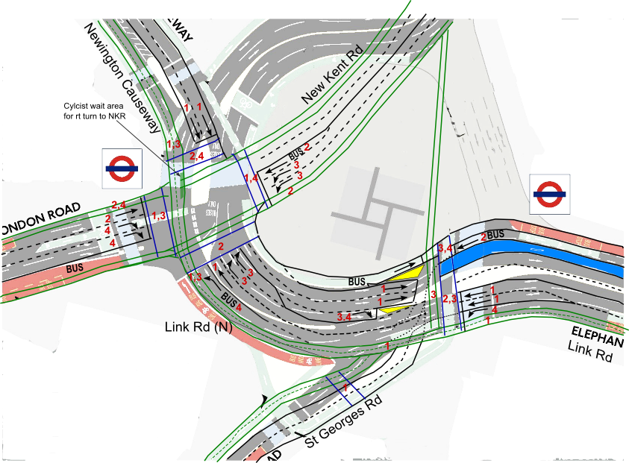
Drawing 2. The complete northern junction with main crossroads, St Georges Rd junction and northern exit/entry to bus interchange area. Superimposed on the TfL consultation drawing to show that we are using broadly the same road space and lane widths. Cycle lanes in green; pedestrian crossings in blue; red numbers correspond to the light phases. Blue filled area – platform for northbound buses.

At the two stop lines where left turns are allowed for motor traffic there would be separate light phases for left and for straight ahead. The left turn from London Rd to Newington Causeway will be banned. There are easy alternatives before and after the northern junction. Pedestrian crossings and bike lanes will run in parallel and will all be single stage. They will have equal time with the motor traffic phases.
We propose that the 100 bus starts in London Road, not Newington Causeway. This simplifies signalling and gives more time for pedestrian crossing. Bidirectional cycle lane continues on the NW side. Cyclists going south cross to join this path at Rockingham St where a cycle crossing already exists.
Four signal phases are needed. However, the ring road phase can be the longest, so it will be possible to have this route green for about 40% of the time.

St Georges Rd T-junction
Here we meet the bus interchange on the right hand side of the road going north. To get buses across it is necessary to signalise southbound traffic. In order to protect cyclists against left turning traffic it is necessary to signalise northbound traffic. As St Georges Rd is 1-way going away, this simplifies matters. Diagram 2 above shows the layout.
The two-way cycle path crosses St Georges Rd and divides. One branch continues to the crossroads, the other runs down the north side of St Georges Rd as proposed in the TfL plan. This branch will presumably be the start of the proposed north-south Cycle Superhighway. Cyclists will also be able to cross at the southern stop line in parallel with pedestrians to join an alternative cycle path across to the New Kent Road. General motor traffic will go in 2 phases, one for traffic going straight, to and from the crossroads (40% of cycle time) and one for traffic turning into St Georges Rd (30%). In addition, two short phases (15% each) would allow (a) north and westbound buses to exit the bus interchange a cross to the left side of the road and (b) pedestrians and cyclists to cross the link road.

Bus Interchange
In order to separate cyclists from buses we propose that the cyclists have the west side of the Link Rd, the buses the east side, and the general motor traffic goes in the middle. This solves the problem that occurs at the moment and is still present in the TfL plan, where cyclists have to intermingle with the buses at the bus stops on the Link Rd. Remember there are 15 daytime routes using the Link Rd. There is plenty of space for an interchange here. The length of the Link Rd, from the southern junction to St Georges is about 100m, enough for nine buses.
As part of the shopping centre and ticket office redevelopments it should be possible to accommodate a new fully integrated passenger interchange, with lifts.

The buses, the Northern Line and the Overground/Network Rail station could have a modern integrated interchange using part of the Link Road and space vacated by the Northern Line ticket office (scheduled for redevelopment). There is an obvious opportunity here for the redeveloped shopping centre; by integrating a transport interchange into plans, one would expect an increase in shopping footfall (as e.g. Hammersmith).

The southern junction
This should have been included in the TfL consultation. TFL propose to continue with the unsafe southbound cycle lane sandwiched between fast traffic lanes. We propose to have separate signal phases for straight on and left turning motor vehicles. In addition, the traffic islands should be removed or greatly reduced to allow in two cases a single stage crossing. A central bus lane is needed for northbound buses to be able to access the bus interchange. The proposed layout is in Drawing 3.
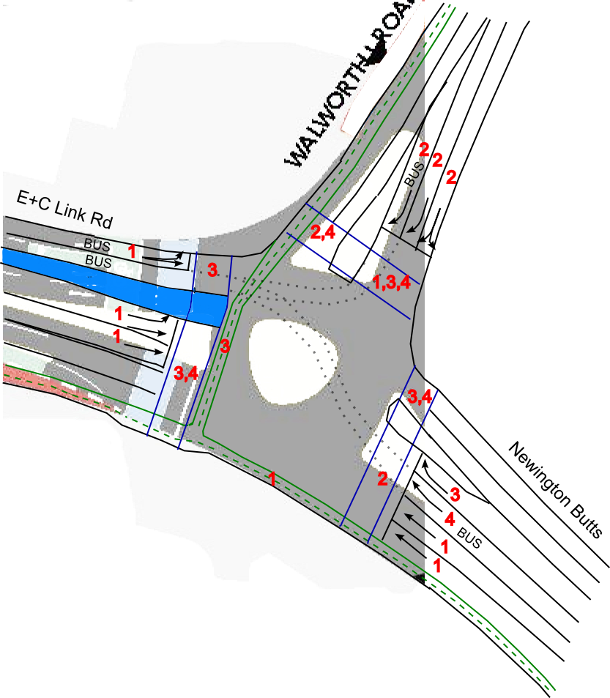
Drawing 3. The southern junction. Green – cycle lanes; blue lines – pedestrian crossings; blue filled area –dismount platform for northbound buses; Red numbers – light phases. Background is copied from TfL consultation document. North to left. Dotted lines across the junction indicate routes for southbound buses. It will be important for buses to wait in the lanes at the two stop lines if the junction is not clear, e.g., when a large bunch of buses arrives at the same time, so that general traffic is not blocked.

Phase 4 can be short as only five bus routes use Newington Butts. Phase 3 needs to be long enough to get pedestrians across the Link Rd. It should be possible to give the ring road phase (1) 40% of time.

Motor traffic capacity across both northern and southern junctions
TfL are keen to maintain motor traffic capacity on the Inner Ring Road. Whatever one may think of this as a policy, we have accepted that our scheme should be as good as the consultation one. We asked TfL for the details of the phasing on their complex double junction. They told us:
Current plans focus on operating the junction in the following sequence: Main (Inner Ring Road) flows – London Rd – Newington Causeway. Signal timings will vary throughout the day according to traffic demand on the various approaches to the junction, ensuring the junction is as efficient as possible. The mode of operation will be UTC SCOOT (Urban Traffic Control - Split Cycle Offset Optimisation Technique) and all timings will be compliant to current DfT standards concerning safety clearance periods and pedestrian, cycle and traffic requirements.
What is clear is that they do not intend to set separate phases for left turning traffic, something that is essential for cyclist safety. Looking at their scheme reveals a problem. The stop lines at Newington Causeway and towards the New Kent Rd are a long distance from those on the peninsular road southwest of London Rd. This means substantial delays on 2 of the 3 phase transitions to allow traffic to clear.
We have worked out a safe version of their scheme with the separated turns and believe they will, like us, need 4 phases. We have also simplified matters a little by banning the redundant left turn from London Rd to Newington Causeway. We think that it will be possible to have just as much “Inner ring road” time, perhaps a little more, at the crossroads than with their scheme made safe.
TfL have no traffic control at the St Georges junction although there will be a light controlled pedestrian crossing. On our scheme, the through traffic can have about 40% of the cycle time. Finally, the extra phases we plan for the southern roundabout will reduce flows there slightly.
Overall, we think that about 40% of green time for two lanes of inner ring road will be enough. Note that there is at present capacity to spare. Queuing is more common at Kennington Lane to the south and at the approaches to Tower Bridge to the North. Therefore, some small loss of capacity at the Elephant is unlikely to put London into gridlock. Certainly, the claim made to us by TfL Engineers that the crossroads would halve capacity at the E+C seems improbable.

